Meeting Minutes
Sprint Planning (goal, user stories selected, tasks)
Sprint Goal:
The goal of Sprint 1 is to establish the foundation of the TutorCircle project by understanding the project requirements, identifying the main system features, dividing responsibilities among team members, and preparing the initial requirements and design documents.
Sprint Planning Discussion:
The team reviewed the SWEN 360 Assignment 1 rubric and TutorCircle project description to understand the expected deliverables. We discussed the foundation features and our two selected advanced features: Demand & Session Insights and Tutor Coordination & Service Quality.
The team also discussed the responsibilities required for Sprint 1 and divided the tasks among all six members.
User Stories:
Haya was assigned to develop the preliminary user stories and identify the different user roles within TutorCircle. The specific user stories are still being prepared and will be finalized before being added to the User Stories Kanban board.
Task Breakdown and Responsibilities:
- Reem (Scrum Master): GitHub repository setup, Kanban board management, meeting minutes, and Scrum Master documentation.
- Hashem: Functional and non-functional requirements and sprint retrospective.
- Haya: Preliminary user stories and user roles.
- Noor: Wireframe design.
- Latifa: High-level system architecture design.
- Mariam: Code and review.
Daily Stand-ups
Stand-up (1) | 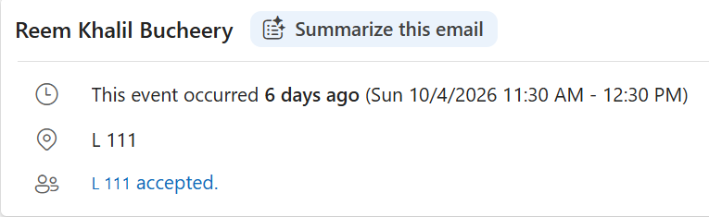
Date: 4 October 2026
Duration: 30 minutes
Attendees: All six team members
Meeting Type: Initial Project Discussion
Meeting Objective:
Review the assignment requirements and understand the TutorCircle project before beginning the work.
Discussion:
- Reviewed the SWEN 360 Assignment 1 rubric and requirements.
- Read through the TutorCircle project description and discussed its main features.
- Brainstormed initial ideas on how to approach the project.
- Identified unclear requirements and prepared questions to ask Dr. Shirazi.
- No tasks were assigned during this meeting, as the focus was on understanding the project.
Decisions Made:
- The team agreed to clarify the confusing requirements with Dr. Shirazi before moving forward.
- Task assignments would be discussed during the next meeting.
Obstcales Faced:
Some project requirements were unclear, making it difficult to determine how to begin the project. The team decided to seek clarification from Dr. Shirazi.
Stand-up (2) | 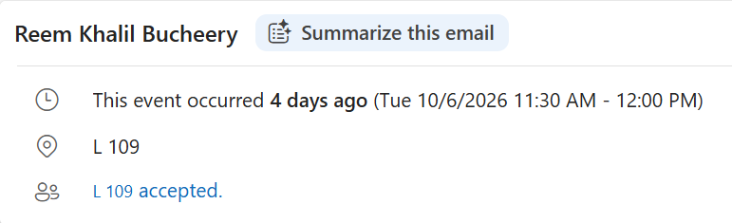
Date: 6 October 2026
Duration: 30 minutes
Attendees: All six team members
Meeting Type: Team Roles and Task Distribution
Meeting Objective
Assign roles and divide the Sprint 1 responsibilities among the six team members.
Discussion
- Discussed the tasks required to complete the Sprint 1 deliverables.
- Began assigning roles and responsibilities to each team member.
- Divided the project work to ensure that each member had a clear responsibility.
Task Distribution
- Reem: Scrum Master, GitHub management, Kanban boards, and meeting documentation.
- Hashem: Sprint retrospective and functional and non-functional requirements.
- Haya: User stories and user roles.
- Noor: Wireframe design.
- Latifa: High-level system architecture design.
- Mariam: Code and review.
Decisions Made
- The team agreed on the division of responsibilities.
- Each member would be responsible for completing their assigned tasks.
- The task distribution would be presented to Dr. Shirazi for approval.
Obstcales Faced:
No new obstcales were reported during this meeting. Clarification of the project requirements was still pending.
Stand-up (3) | In-Class Meeting with  Dr.Shirazi
Date: 8 October 2026
Duration: 15 minutes
Attendees: All six team members and Dr. Shirazi
Meeting Type: Project Clarification and Task Approval
Meeting Objective
Clarify the project requirements and receive approval for the team's assigned responsibilities.
Discussion
- Met with Dr. Shirazi to discuss unclear TutorCircle project requirements.
- Asked questions regarding the project details to ensure the team understood the expectations.
- Presented the responsibilities assigned to all six team members.
- Requested confirmation that the team was working in the correct direction.
Decisions Made
- Dr. Shirazi reviewed and approved all six members' assigned tasks.
- The team confirmed that the task distribution was appropriate.
- The team agreed to continue working according to the approved responsibilities.
- The initial confusion regarding project requirements was addressed through consultation with Dr. Shirazi. The team received the necessary clarification and approval to move forward.
Obstcales Faced:
No new obstcales were reported during this meeting.
Stand-up (4)

